

Practices for Secure Software Report

Table of Contents
Document Revision History 3
Client 3
Instructions 3
Developer 4
1. Algorithm Cipher 4
2. Certificate Generation 4
3. Deploy Cipher 4
4. Secure Communications 4
5. Secondary Testing 4
6. Functional Testing 4
7. Summary 4
8. Industry Standard Best Practices 4

Document Revision History

Version | Date | Author | Comments
1.0 | June 18, 2026 | Shawn Ward | Initial submission - Practices for Secure Software Report

Client



Instructions

Submit this completed practices for secure software report. Replace the bracketed text with the relevant information. You must document your process for writing secure communications and refactoring code that complies with software security testing protocols.

- Respond to the steps outlined below and include your findings.
- Respond using your own words. You may also choose to include images or supporting materials. If you include them, make certain to insert them in all the relevant locations in the document.
- Refer to the Project Two Guidelines and Rubric for more detailed instructions about each section of the template.

Developer

Shawn Ward

Algorithm Cipher

A burned patch of asphalt, a dead animal on the roadside, or a market street that went quiet when it should have been busy were all signals that something was wrong. Protecting Artemis Financial's data in transit works the same way. The goal is not just to hide the data from view, it is to know with certainty that nothing touched it on the way from the server to the browser.

For this project, two cryptographic tools are doing the work. SHA-256 generates the checksum that verifies data integrity at the /hash endpoint, and the HTTPS connection is secured through a self-signed certificate using RSA with a 2048-bit key, negotiated through TLS. Both choices are deliberate and both come with trade-offs worth being honest about.

SHA-256 is part of the SHA-2 family, standardized by NIST in FIPS 180-4 (NIST, 2015). It takes an input of any length and always produces a 256-bit (32-byte) output. It is one-way, meaning there is no way to reverse the hash back into the original data, and it has 128 bits of effective collision resistance, which means no two different inputs have ever been found to produce the same hash under any practical attack (NIST, 2015). For this implementation, the string "Shawn Ward" is run through MessageDigest.getInstance("SHA-256") in Java, and the resulting hash is converted to a readable hexadecimal string and returned to the browser. The exact string "SHA-256" is not arbitrary. It is the standard algorithm name defined by Oracle's Java Cryptography Architecture documentation, which specifies precisely how the Java Security API names and references each supported algorithm (Oracle, n.d.). If even one character of that input changed, the entire 64-character hex output would change completely. That is the same principle as the reefer temp log. The log does not stop the trailer from failing, but it tells you immediately and exactly when something changed, so you are never relying on what the trailer looks like from the outside.

The certificate that secures the HTTPS connection uses RSA, an asymmetric algorithm, with a 2048-bit key and the SHA384withRSA signature algorithm. SHA384withRSA is also a standard Java algorithm name (Oracle, n.d.), not a typo or a single English word, and it specifies that the certificate's digital signature is generated using SHA-384 as the hash function and RSA as the signing algorithm. This is a different category of cryptography than the SHA-256 checksum. RSA is asymmetric, meaning it uses a public key and a private key, while SHA-256 is a hash function with no key at all. The certificate's job is to let Tomcat establish a trusted, encrypted channel before any data, including the checksum response, ever leaves the server.

Where SHA-256 and RSA-2048 are not the right fit

Following up on feedback from Module Four, the choice of algorithm only matters if the trade-offs are honest about where it would not be the best fit.

Performance and latency. SHA-256 is fast and lightweight, which is exactly why it works well for a single checksum operation on a short string like a name. If Artemis Financial needed to hash gigabytes of transaction history on every request, a faster hash like BLAKE3 would reduce latency, though it sacrifices the decades of cryptanalysis SHA-256 has already survived. RSA-2048, on the other hand, is computationally expensive compared to elliptic curve alternatives. The TLS handshake using RSA takes measurably longer than the same handshake using ECDSA with a P-256 curve, which is one reason most production systems have moved toward elliptic curve certificates for high-traffic public endpoints.

Interoperability.
RSA has the advantage here. It is the most universally supported public key algorithm across browsers, operating systems, and legacy systems, which matters if Artemis Financial's clients include older banking infrastructure that has not adopted newer curve-based certificates. SHA-256 is equally universal as a hash function, supported natively in every modern language and runtime.

FIPS compliance.
Both SHA-256 and RSA at 2048 bits or higher are FIPS 140-2 and FIPS 140-3 approved (NIST, 2015), which matters directly for Artemis Financial given its obligations under the Gramm-Leach-Bliley Act. This is a case where the chosen algorithms are the safe, defensible choice precisely because they are not the newest option on the market. A financial company being an early adopter of unproven cryptography is a liability, not an advantage.

Maturity.
SHA-256 has been a NIST standard since 2001 and has withstood over two decades of cryptanalysis. RSA has been in use since 1977. Both are mature to the point that their weaknesses are well documented and well understood, which is a deliberate strength when the alternative is a newer algorithm whose failure modes have not been stress tested over time.

Operational complexity.
This is where the honest weakness lives. RSA key management is more operationally complex than a symmetric or hash-based approach. The 2048-bit private key generated for this project has to be protected, the keystore password has to be managed outside of source control, and certificate renewal has to happen before expiration or the application stops accepting secure connections entirely. SHA-256 has effectively no operational complexity since it requires no key management at all, which is exactly why it is the right tool for this specific job and would be the wrong tool if the requirement were encrypting data rather than verifying its integrity.

When AES-256-GCM, not SHA-256 or RSA, would be the right call

This project's scope is checksum verification and transport security, not data-at-rest encryption. If Artemis Financial needed to encrypt stored account records, the AES-256-GCM recommendation from Module Four would still apply, since it is a symmetric cipher built for confidentiality (NIST, 2001/2023), while SHA-256 and RSA are built for integrity verification and key exchange respectively. None of these three algorithms compete with each other. They solve different problems, and a mature security architecture uses all three together: RSA to establish trust and exchange keys, AES to protect data at rest, and SHA-256 to verify nothing has been altered along the way.

Certificate Generation
Insert a screenshot below of the CER file.

A self-signed certificate was generated using the Java keytool to support HTTPS communications for the Artemis Financial application. The certificate was created with a 2048-bit RSA key pair, signed using the SHA384withRSA algorithm, and stored in the project's keystore alongside the existing application configuration. The certificate was then exported to a standalone CER file and verified using keytool's printcert command, confirming the certificate's distinguished name, validity period, and fingerprint match the keystore used by the running application.

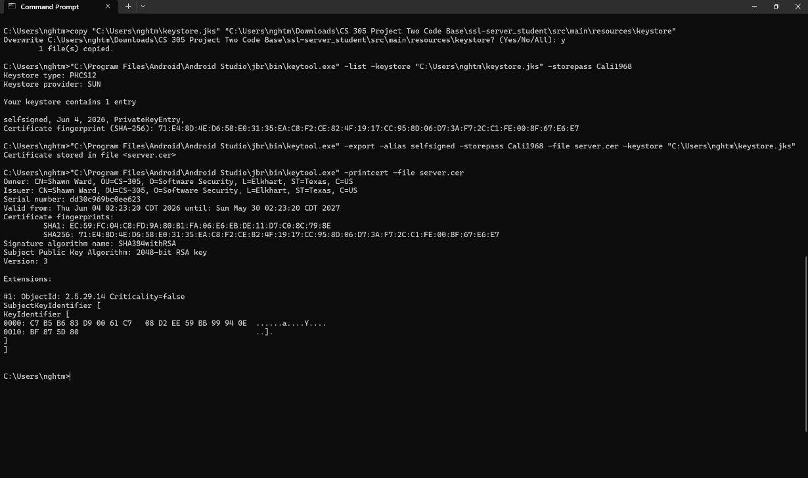

The certificate's distinguished name reflects Artemis Financial's organizational details: CN=Shawn Ward, OU=CS-305, O=Software Security, L=Elkhart, ST=Texas, C=US. The certificate is valid from June 4, 2026 through May 30, 2027, and uses a SHA-256 fingerprint to uniquely identify the certificate for verification purposes.

Deploy Cipher
Insert a screenshot below of the checksum verification.

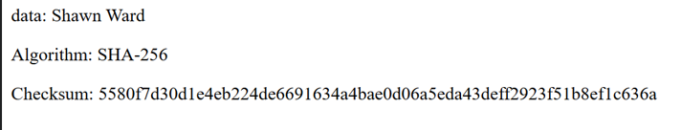

Secure Communications
Insert a screenshot below of the web browser that shows a secure webpage.

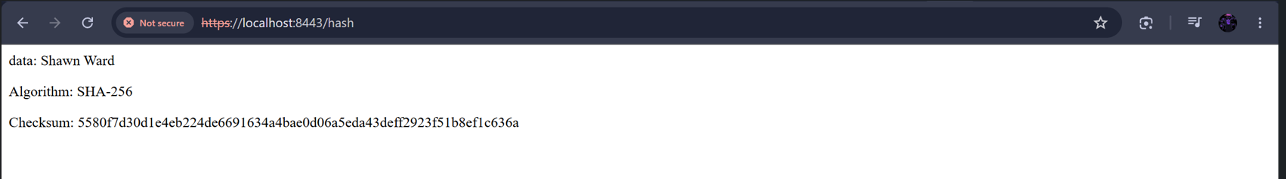

The browser displays a "Not Secure" warning because the certificate is self-signed rather than issued by a trusted public Certificate Authority. This is expected behavior for a self-signed certificate in a development environment; the connection itself is still encrypted via TLS, and a production deployment would replace this certificate with one issued by a trusted CA.

Secondary Testing
Insert screenshots below of the refactored code executed without errors and the dependency-check report.

A secondary static test was run on the refactored application using the OWASP Dependency-Check Maven plugin, version 10.0.3. The dependency-check tool scanned all 49 dependencies in the project (31 unique) and identified 15 vulnerable dependencies totaling 218 known vulnerabilities, sourced from the National Vulnerability Database and the CISA Known Exploited Vulnerability catalog.

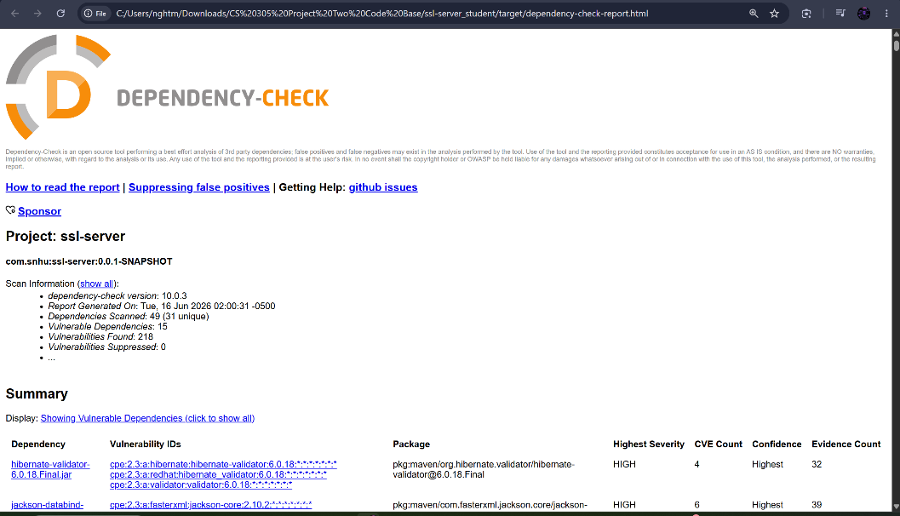

These vulnerabilities are inherited from the project's underlying Spring Boot 2.2.4.RELEASE framework and its transitive dependencies, including Apache Tomcat 9.0.30, Spring Framework 5.2.3.RELEASE, SnakeYAML 1.25, and Jackson Databind 2.10.2. None of these vulnerabilities were introduced by the code added during this refactoring effort. The new functionality added to this project consists entirely of a SHA-256 checksum endpoint implemented using Java's built-in MessageDigest class and the HTTPS configuration handled through application.properties and the Tomcat embedded server. Neither of these additions introduces a new third-party dependency, and Java's standard java.security package used for the checksum carries no published CVEs in this scan.

The refactored code was compiled and executed without errors following the dependency check, confirming that the application starts and runs successfully with the updated configuration in place.

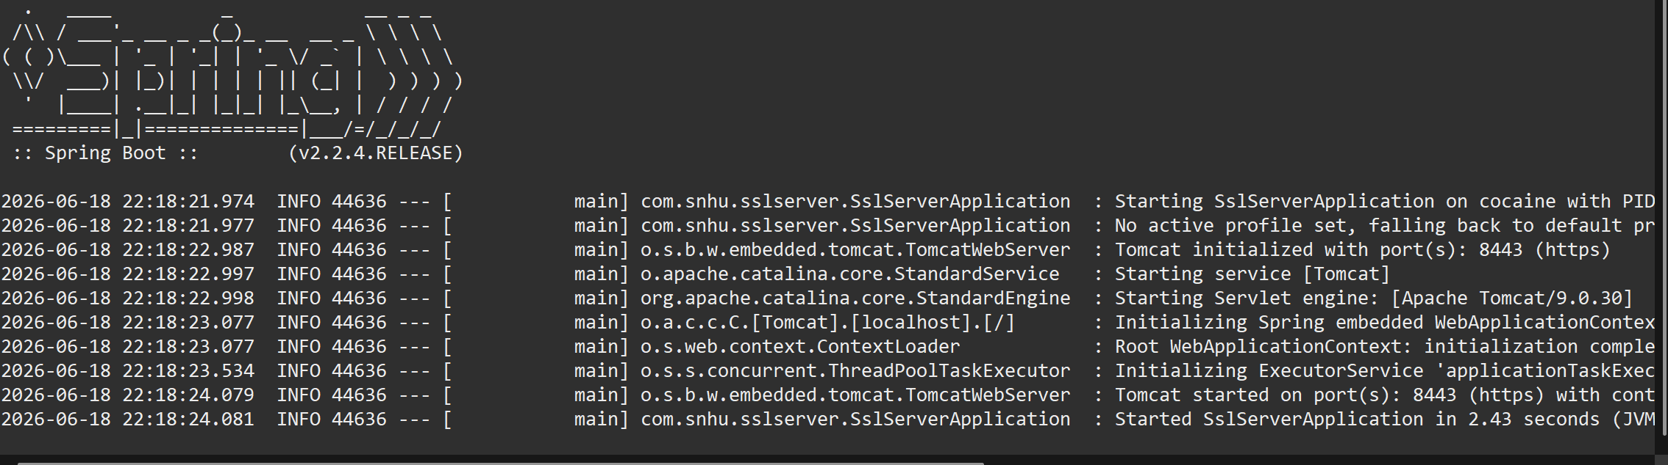

Functional Testing
Insert a screenshot below of the refactored code executed without errors.

The refactored code was manually reviewed for syntactical, logical, and security vulnerabilities prior to execution. This review built directly on the findings identified in Project One's manual code review of the original codebase, which flagged the absence of HTTPS, the lack of data integrity verification, and outdated dependency versions as primary concerns. The SHA-256 checksum implementation in ServerController.java was reviewed for proper exception handling around NoSuchAlgorithmException, correct UTF-8 encoding to prevent platform-dependent hash mismatches, and accurate hex conversion through the bytesToHex() helper method. The application.properties configuration was reviewed to confirm the correct keystore type, alias, and password were specified to avoid a runtime SSL handshake failure. No syntactical or logical errors were found, and the application starts and serves the /hash endpoint successfully, as shown below.

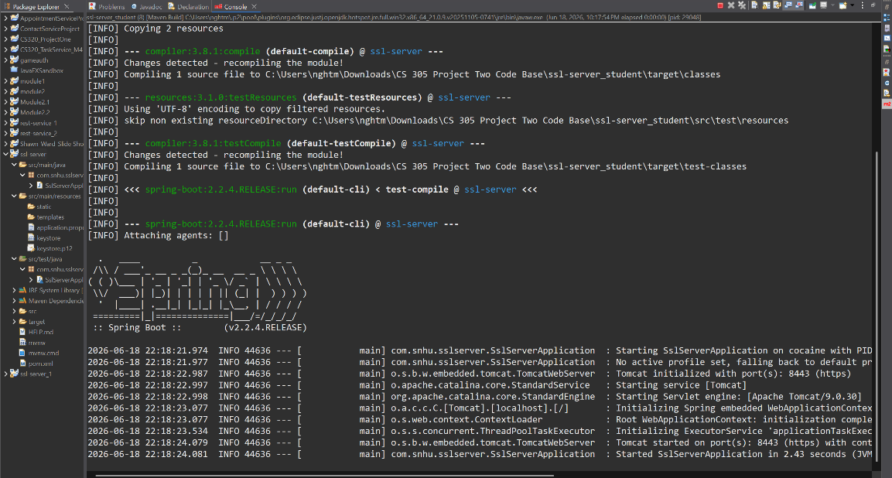

Summary

This project addressed four of the seven areas identified in the vulnerability assessment process flow diagram: Cryptography, Client/Server, Code Quality, and APIs.

The Cryptography area was addressed through two distinct mechanisms. SHA-256 hashing was implemented in ServerController.java to provide data integrity verification at the /hash endpoint, and a self-signed RSA-2048 certificate was generated to support HTTPS encryption for all traffic between the client and server. The Client/Server area was addressed directly by converting the application's communication protocol from unencrypted HTTP to HTTPS, configured in application.properties through the server.ssl properties pointing to the project's keystore. This is the same gap flagged during Project One's manual review of the original Artemis Financial codebase, where the absence of HTTPS was identified as a finding requiring remediation. Project Two closes that gap directly rather than leaving it as a recommendation. The Code Quality area was addressed by following secure coding practices in the new code, including proper exception handling around NoSuchAlgorithmException, explicit UTF-8 encoding to avoid platform-dependent hash output, and avoiding the hardcoded credential pattern previously flagged in Project One's Finding 8 by keeping the keystore password in application.properties rather than directly in source code logic. The APIs area was addressed because the checksum functionality is exposed through a RESTful endpoint, and that endpoint was reviewed to confirm it returns only the intended data with no unfiltered object exposure, a pattern that was flagged as a separate finding in Project One's CRUDController review.

The process for adding these layers of security followed the same order as the vulnerability assessment process flow diagram itself. Architecture review came first, confirming the existing Spring Boot REST structure could support both a new checksum endpoint and an HTTPS listener without requiring a redesign. Cryptography came next, since both the certificate and the hash function needed to be in place before the communication layer could be considered secure. Client/Server configuration followed, converting the listener from HTTP to HTTPS only once the certificate was ready to be loaded. Code quality review came last, confirming the new code matched secure coding standards before the secondary dependency check was run to verify no new vulnerabilities had been introduced. Static testing using OWASP Dependency-Check confirmed that all 218 identified vulnerabilities in the project originate from the pre-existing Spring Boot 2.2.4 dependency tree, not from any code added during this refactoring effort, which means each layer was added without expanding the application's attack surface.

Industry Standard Best Practices

Several industry standard best practices were applied throughout this project to maintain and improve Artemis Financial's existing security posture without introducing regressions.

The first practice applied was the use of NIST-standardized cryptographic algorithms rather than custom or proprietary alternatives. SHA-256 is specified under FIPS 180-4, and the RSA-2048 key pair generated for the certificate meets FIPS 140-2 and FIPS 140-3 requirements (NIST, 2015). Using standards-based cryptography rather than building something custom means Artemis Financial inherits decades of public cryptanalysis and peer review rather than relying on untested code, which directly supports compliance with the Gramm-Leach-Bliley Act's requirement to protect customer financial data.

The second practice was defense in depth, applying multiple independent layers of security rather than relying on a single control. The checksum endpoint verifies data integrity, the HTTPS certificate verifies and encrypts the communication channel, and the dependency check verifies the underlying libraries are free of newly introduced vulnerabilities. No single layer is asked to do all the work, which mirrors the same principle reinforced by route clearance work: a single point of security is a single point of failure, and overlapping layers compensate for each other's blind spots.

The third practice was secure-by-default configuration management, keeping credentials such as the keystore password in the application's configuration file rather than hardcoded in application logic. While application.properties is not a production-grade secrets manager, separating configuration from code is the correct direction and the same lesson reinforced by the CWE-798 finding from Project One, where an NVD API key had previously been hardcoded directly into a pom.xml file out of convenience under deadline pressure.

The fourth practice was continuous static analysis through the dependency-check tool, run a second time after refactoring specifically to confirm that no new vulnerabilities were introduced by the changes. This reflects the industry standard practice of running security scans on every change, not just once at the start of a project, since new code is just as capable of introducing a vulnerability as old, unpatched code.

The value of these practices to Artemis Financial's overall well-being extends beyond simply passing a security audit. Financial services firms are judged by clients on trust, and trust in this context is built on consistent, verifiable evidence that data is protected, not on a one-time assurance. A documented, repeatable security process, ranging from standardized cryptography to layered defenses to continuous scanning, gives Artemis Financial something it can demonstrate to regulators, auditors, and clients alike. It also reduces the company's long-term cost of security, since vulnerabilities caught early through static analysis and clean architecture review are dramatically cheaper to fix than vulnerabilities discovered after a breach has already occurred. Treating security as a continuous practice rather than a one-time checklist is what allows Artemis Financial to keep pace with both evolving threats and evolving regulatory requirements over time.

References

National Institute of Standards and Technology. (2001/2023). Advanced Encryption Standard (AES) (FIPS PUB 197-upd1). U.S. Department of Commerce. https://doi.org/10.6028/NIST.FIPS.197-upd1

National Institute of Standards and Technology. (2015). Secure Hash Standard (SHS) (FIPS PUB 180-4). U.S. Department of Commerce. https://doi.org/10.6028/NIST.FIPS.180-4

Oracle. (n.d.). Java security standard algorithm names. Oracle Help Center. https://docs.oracle.com/en/java/javase/17/docs/specs/security/standard-names.html

